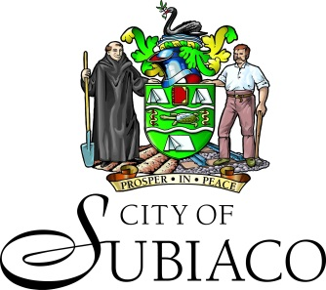

NOTICE OF GAZETTAL WASTE LOCAL LAW 2022
The City of Subiaco has made a Waste Local Law 2022 which will come into effect on 28 March 2023.
The purpose and effect of the law is to assist the City in administering sustainable waste and recycling services to maintain consistent, cost effective and functional waste management practices to aid in the reduction of waste to landfill.
The local law may be inspected at the City of Subiaco Administration at 19 Bishop Street, Jolimont between the hours of 9.00am – 4.30pm on weekdays.
Alternatively, an electronic copy can be viewed on the City of Subiaco website here.
COLIN CAMERON
CHIEF EXECUTIVE OFFICER

