Infrastructure and Verge Asset Protection

Development Inspection Fee

The Development Inspection fee has been introduced to evaluate the condition of City infrastructure and verge assets situated adjacent to proposed developments. The development inspection fee covers a pre and post inspection of the condition of the City’s assets adjacent to the licenced development.
The fee of $210 is a non-returnable fee, levied in accordance with the City’s Schedule of Fees and Charges published in the City’s annual Budget.
The pre development site inspection evaluates the pre-existing condition of the City assets including, but not limited to, footpaths, kerbs, roads, drainage systems, street lighting, signage, road markings, street trees and reticulation adjacent to the development. Following the completion of the works and submission of a BA7- Notice of Completion, a post development inspection assesses and reports if any damage has occurred to city assets as a result of the development works. In addition the non-refundable inspection fee covers all the associated administration documentation relating to the development, inclusive of pursuing any damages that may have occurred to City assets.

The property owner is responsible for all development works, engaged contractors and ensuring that the City’s infrastructure and verge assets are protected during the development, in accordance with Local Government Regulations 1996 and Local Government Act 1995.

Damages to City assets are managed according to the City’s Activities and Thoroughfares and Public Places Local Law 2014, sections 7.3, 8.1 & 8.2

7.3 Notice to repair damage to thoroughfare
Where any portion of a thoroughfare has been damaged, the local government may by notice to the
person who caused the damage order the person to repair or replace that portion of the thoroughfare
to the satisfaction of the local government.

Part 8 – Enforcement
8.1 Offence to fail to comply with notice
Whenever the local government gives a notice under this local law requiring a person to do anything, if the
person fails to comply with the notice, the person commits an offence.

8.2 Local government may undertake requirements of notice
Where a person fails to comply with a notice referred to in clause 8.1, the local government may do the
thing specified in the notice and recover from that person, as a debt, the costs incurred in so doing.

In the instance the damage is considered a public safety concern, a 24hr notice will be issued to the owner for immediate rectification. If the owner is unable, or does not wish to comply with the 24hr notice the City will ensure the damages are addressed and seek reimbursement as per the Local Government Act 1995 and Activities in Thoroughfares and Public Places Local Law 2014.
City Officers closely monitor all licenced development works to ensure compliance with building/ permit conditions and ensuring community safety and streetscape amenity are a priority.
Commercial Developments

All commercial developments will be levied the same non-refundable inspection fee but in addition the developer will be required to pay a development bond. The amount of the development bond is assessed individually with the final bond amount determined upon application. The city’s commercial development bond is based on the surrounding asset replacement value, which includes, but is not limited to, footpaths, kerbs, roads, drainage systems, street lighting, signage, road markings, street trees and reticulation. Pre-development images are taken of the site, adjacent surrounds and City assets documenting their existing condition. The development inspection fee and bond is to be paid following approval and prior to the issue of a Building License/Permit.

The property owner is responsible for all development works, engaged contractors and ensuring that the City’s infrastructure and verge assets are protected during the development, in accordance with Local Government Regulations 1996 and Local Government Act 1995.

Damages to City assets are managed according to the City’s Activities and Thoroughfares and Public Places Local Law 2014, sections 7.3, 8.1 & 8.2

If following the completion of the commercial development damage to City infrastructure assets are identified there are two options regarding commercial reinstatement:

- The person who lodged the bond may undertake the reinstatements ensuring the works meet the original standard and specification
- With the party’s consent, the City of Subiaco will arrange for the reinstatement to be undertaken, and the costs of reinstatement will be deducted from the bond.

If reinstatement works are undertaken by the person who lodged the bond, an additional inspection is conducted following notice to re inspect. If the reinstatement works meet the standard and specification originally approved and accepted by the City of Subiaco, the bond, less the costs of reinstatement incurred (if applicable) will be refunded to the original payee of the bond. The City’s bond refund process takes approximately four weeks.

Sediment Control
Developers are required to implement sediment control measures on their development sites. The migration of sediment onto the road reserve and into drains not only affects the amenity of the area, but has major negative environmental impacts on the City’s waterways and parks. On-site benefits to builders who adopt appropriate sediment control measures include savings from reduced stockpile losses, reduced clean-up costs, improved Occupational Health and Safety and fewer complaints from the public.
Please refer to the Sediment Control for Building Sites brochure for six practical ways to achieve compliance and avoid being charged with sediment migration offences under the Environmental Protection (Unauthorised Discharges) Regulations 2004 and the Local Government Act 1995.

Redundant Crossings / Crossovers
Crossings (also known as crossovers) provide vehicle access to properties through City verges. Crossings are to be maintained by the owner of the property. If development works cause any existing vehicle crossing to become redundant (that is, no longer giving access from a thoroughfare to a lot), then that crossing is to be removed and the affected infrastructure reinstated to the satisfaction of the City at the cost of the owner. For more information, refer to Activities in Thoroughfares and Public Places Local Law 2014 Part 2.5 Removal of Redundant Crossing.

Development works resulting in a new carport or garage, or amendments to an existing crossover require a crossover application to be completed.

Tree protection
The contractor shall protect the city's street trees from any damage that may be caused by the scope of works covered by the Development Application or Building License/Permit for the duration of the works by complying with the Australian Standard relating to the protection of trees on or adjacent to development sites (AS 4970–2009).

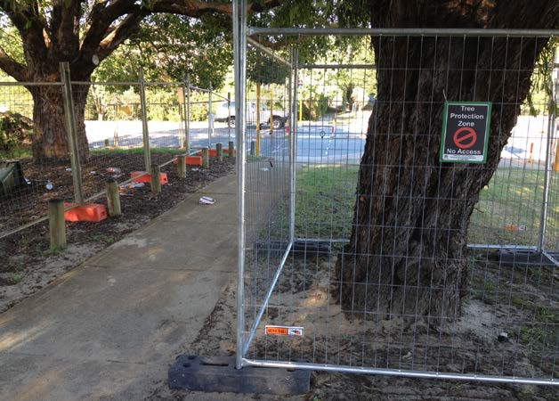
Tree Protection Zone (TPZ) is to be established and maintained around each street tree for the life of the application/permit. The minimum TPZ required is two (2) metres x two (2) metres.

Nothing is to be stored, driven or parked within the TPZ. Should any essential work or variation to the Australian Standard be required within the TPZ, the contractor is to contact Technical Services to arrange an onsite meeting to discuss the city’s requirements.

No tree branches or roots from the verge tree are to be cut without the authorisation of the City's arborist. Roots approved for cutting are to be cut in accordance with the appropriate arboricultural standards. Where one or more structural roots are identified within the work zone and root pruning is not recommended, alternatives are to be considered in consultation with the City's Parks Technical Officer – Urban Forest and/or Coordinator Infrastructure.

To minimise the risk of tree damage/death a minimum construction clearance of two (2) meters is required from the base of an existing street tree. Where excavation to a depth greater than 100mm is proposed the clearance should be greater than three (3) meters from the base of an existing street tree.

All site work will be regularly monitored to ensure compliance with this specification.

Verge preservation
The underlying principle of the City’s approach to managing verges in the road reserve is to encourage residents to:

- install and maintain soft landscaping which contributes to the aesthetic presentation of the streetscape
- apply sound environmental consideration to verge development through utilising low water demand plantings of species indigenous to the local area
- minimise the use of impervious surfaces to encourage infiltration of ground water
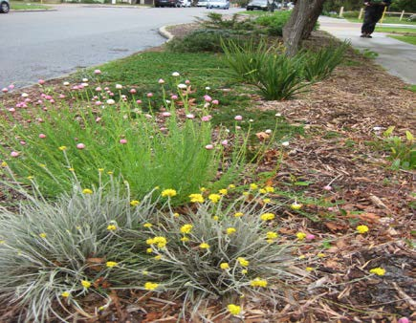
- and meet the communities requirements for safety.

Residents do not require approval to install the following verge treatments, provided the verge policy management guidelines are adhered to:

- organic mulch
- low growing water wise verge gardens
- a natural lawn at a grade consistent with existing kerbs and footpaths.

Residents require pre-approval for the following verge treatments:

- excavation to any portion of the verge to any depth greater than 100mm
- installation of any paving or hard surface
- planting a street tree.

Verge paving applications
In order for verge paving proposals to be assessed the property owner is required to submit a proposed paving plan with a diagram that illustrates the location, alignment, and materials.

Proposals for verge paving will be considered by the City of Subiaco:
- when the property cannot accommodate two vehicles within the property
- where there is a legitimate requirement for verge parking with no reasonable alternative
- where the installation of paving to the verge will not compromise the longevity of an existing street tree

- where the paving is proposed to provide a footpath between the property boundary and the kerb line, the proposed path is 1.5 metres wide as per the example image below.

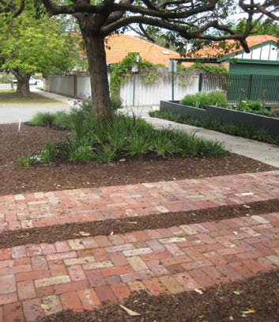

Further information can be obtained from the city’s website www.subiaco.wa.gov.au or by calling Operations and Environment on 9237 9222.

