CITY OF SUBIACO
LOCAL PLANNING POLICY 8.2
Advertisements (Signs)

ADMINISTRATIVE

Version | Date | Comment
1.0 | 29 April 2003 | Adoption date
2.0 | 23 August 2016 | Review date
3.0 | 23 March 2021 | Review date
3.1 | 20 July 2021 | Draft for public advertising
4.0 | 23 November 2021 | Final for publishing

AUTHORITY
- Planning and Development (Local Planning Schemes) Regulations 2015 (LPS Regulations)
- City of Subiaco Local Planning Scheme No. 5 (Scheme)

STATUTORY BACKGROUND
This local planning policy (the policy) is made pursuant to Schedule 2, Part 2, Division 2 of the Planning and Development (Local Planning Schemes) Regulations 2015 relating to local planning policies.

Advertisements are defined in Part 1 of the Deemed Provisions and include signs.

Clause 61(1) of the Deemed Provisions exempts the erection or installation of a sign of a class specified in a local planning policy from the need to obtain planning approval, subject to the conditions of Clause 61(1), row 10, column 2. Development approval is required for signs erected or installed on heritage-protected places.

Advertisements within the road reserve or public places and not located on private property are subject to the City’s Activities in Thoroughfares and Public Places Local Law.

PURPOSE
The purpose of this policy is to ensure that the display of advertisements does not adversely impact upon the amenity of the existing streetscape while providing appropriate exposure of activities or services.

APPLICATION
This policy applies to all proposals relating to new advertisements in the Scheme area in conjunction with the Scheme and any other relevant local planning policies.

Section 4.0 of this policy does not apply to advertisements in the Rokeby Road and Hay Street Heritage Area. Refer to the Local Planning Policy relating to Development Guidelines for the Rokeby Road and Hay Street Heritage Area for specific provisions relating to advertisements in this heritage area.

POLICY
- Objectives
The objectives of this policy are to:
- ensure that the display of advertisements does not adversely impact the amenity of surrounding land or the broader locality;
- improve the quality and appropriateness of advertisements through the application of sound design principles;
- consolidate advertisements where appropriate;
- limit the proliferation of advertisements; and
- ensure that advertisements do not present a hazard or obstruction to pedestrians or block motorists’ views of traffic information signs or traffic lights.

- Definitions
- The following terms are defined for the purpose of this policy:

Advertisement | means signs and signage.
Aggregate area | means the total, combined surface area of each instance of that type of sign on a site.
Deemed Provisions | means the provisions contained in Schedule 2 of the Planning and Development (Local Planning Schemes) Regulations 2015.
Scheme | means City of Subiaco Local Planning Scheme No. 5 (LPS 5).
Sign area | means the portion contained within a polygon drawn around the text, graphics and/or image and not the entire background provided that the colour of the background of the sign does not substantially differ from the colour of the surface to which the sign is attached.
Signage Strategy | means an overall plan for the whole of the tenancy, site or area, showing the location, type, size and design of all existing and proposed signs, as well as the outline of any builidings, landscaping, car parking areas, vehicular access points etc.
- All other terms, words and expressions used in this policy have the same meaning as they have in the Scheme.

- Types of signs
Table 1 defines different types of signs for the purposes of this policy.

Table 1: Types of signs
Sign | Definition | Example
Above roof sign | An advertisement that protrudes above the normal roofline of a building. | 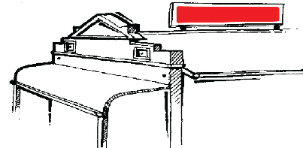
Above verandah sign | An advertisement placed perpendicular to the façade of a building above a verandah or awning. | 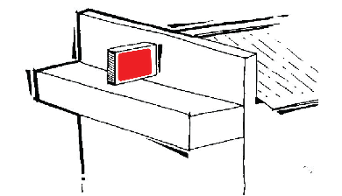
Awning sign | An advertisement fixed to the outer or return fascia of an awning or verandah, and includes signs on blinds, sunshades and similar structures. | 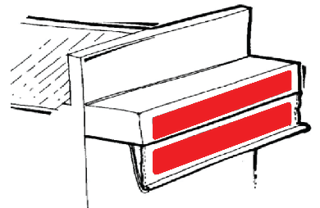
Balloon or blimp sign | An advertisement printed on a balloon or similar device and flown above the advertised premises. | 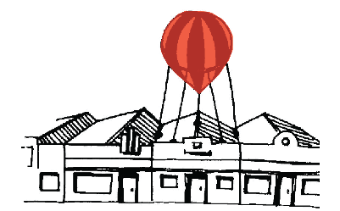
Bus shelter sign | An advertisement within an existing signage casing that is placed on or within the framework of a bus shelter. | 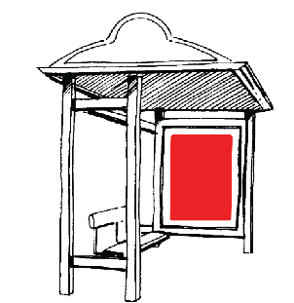
Construction site sign | A temporary advertisement erected at a building site that informs the public about the development and various companies involved, and may include a graphical respresentation of the development for informative purposes. The advertisement is associated with construction works and typically does not present long term amenity impacts.  The advertisement typically comprises a sign supported on post(s) or a hoarding sign. | 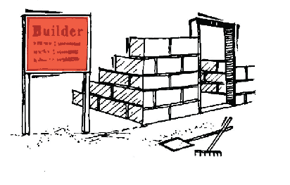
Flag sign | An advertisement that is printed onto a flag (typically flown from a pole). | 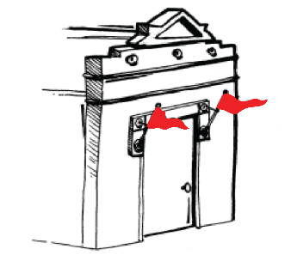
Freestanding panel sign | A large freestanding advertisement, typically supported on posts. | 
Hoarding sign | An advertisement that is fixed to or forming part of a temporary structure, such as a hoarding or scaffold used to fence off, cover or wrap a building or land during construction. | 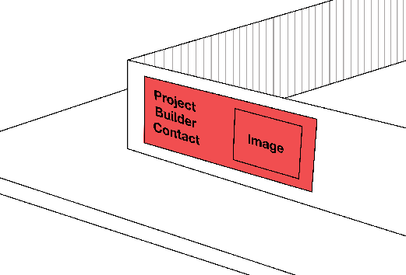
Home occupation or home business sign | An advertisement associated with a home occupation or home business. | -
Panel sign | An advertisement that is attached to a panel and mounted onto an existing vertical structure such as a side fence. | 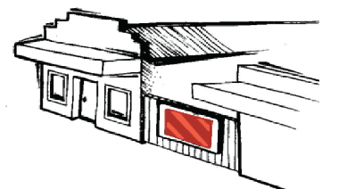
Plaques or plates | Means a sign attached to a building near its entrance that lists the occupants of the premises, and may include their occupation or profession or the business name. | 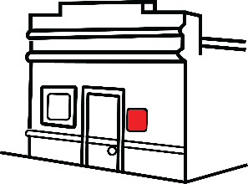
Portable sign | A freestanding portable advertisement (including an A-frame sign) that is usually placed directly outside the premises to which it relates. | 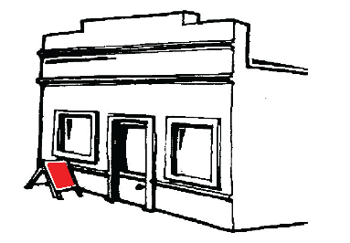
Property sale or lease sign | An advertisement that is placed on or in front of a building or site, with the intention of advertising the sale or lease of that building or site. | 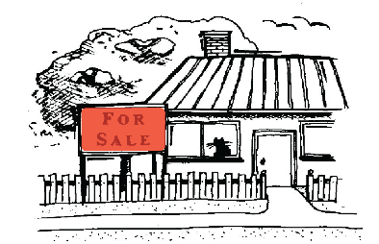
Projecting sign | An advertisment placed perpendicular to the facade of a building (but excludes under verandah signs and above verandah signs). | 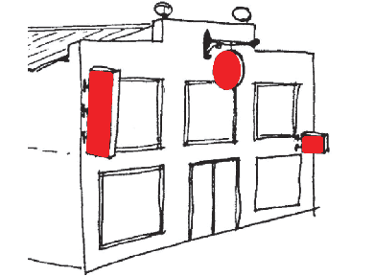
Pylon Sign | A stand alone advertisment (including a monolith sign) supported by one or more piers or columns and not attached to a building. | 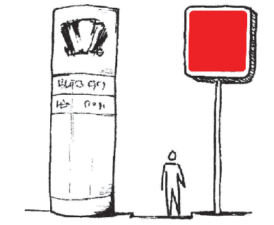
Roof sign | An advertisement that is painted on or mounted flush to the roof of a building. | 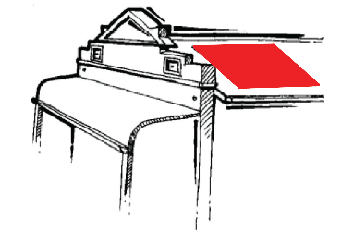
Temporary sign | An advertisement that is not permanently attached and will be erected for not more than 4 weeks in any calendar year. | -
Temporary event sign | An advertisement that typically advertises short term events within the district, is not permanently attached and will be erected for not more than 4 weeks in any calendar year. | -
Third party sign | An advertisement displaying information that does not relate to the site or building on which the sign is located. | -
Under verandah sign | An advertisement placed perpendicular to the facade of a building located under a verandah or awning. | 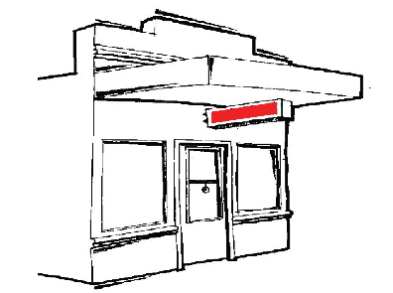
Wall sign | An advertisement attached or painted directly onto an external wall of a building. | 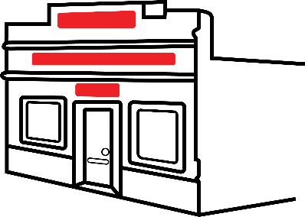
Window sign | An advertisement attached to a window of a building, or which is located in the interior of a building and up to 0.6m behind a window. | 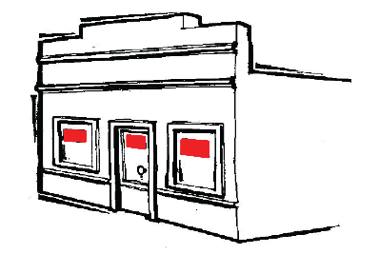

- Exemption from the need to obtain development approval
  - Pursuant to clause 61(1) of the Deemed Provisions, advertisements are exempt from the requirement to obtain planning approval if they satisfy the conditions of Clause 61(1), row 10, column 2 – conditions and:
    - All specific conditions are met as set out in Table 2 of this policy; and
    - The proposal does not result in more than five individual advertisements per tenancy; and
    - The proposal does not include any advertisement which contains any illumination or radio animation or movement; reflective; retro-reflective; and fluorescent materials in its design or structure unless otherwise stated in Table 2.

  - Where an exemption is sought for a type of sign in Table 2, the applicant must seek written confirmation from the City that the exemption can be applied to the proposed sign. The applicant shall provide the following information as part of a written exemption request:
    - Signage details, including dimensions, content and design, colours;
    - Plans depicting the proposed signage in relation to the subject building and site, including a site plan and elevation plan(s); and
    - Illumination details, including the nature of illumination, hours of illumination, and compliance of the illumination with the relevant Australian Standards.
The City may request any other information deemed necessary to consider exempting a sign under this policy, such as additional signage details or plans.

Table 2: Exempted Advertisements
Type of sign | Conditions
Awning sign | - Located in the Centre, Mixed Use or Local Centre zone;  - One per street frontage of the subject tenancy;  - Contained within the width of the building; and  - A sign area of 0.4m² per 1m of street frontage, to a maximum of 10m².
Bus shelter sign | - Maximum sign area of 3m² (or 6m² in the case of a double-sided sign).
Construction site sign | - Located in the Centre, Mixed Use, Local Centre or Residential zone, within the boundaries of the subject site;  - One per street frontage of the subject site containing the details of the project, professional consultants, contractors and/or builders, and may contain a graphical representation of the project for informative purposes;  - Maximum sign area:  - Sites less than 2500m² = 2m²  - Sites 2500m² – 5000m² = 4m²  - Sites greater than 5000m² = 6m²;  - Displayed only for the duration of the construction;  - May be illuminated in a manner that does not flash or pulsate, and does not result in light spill onto the road or adjoining properties. The illumination of the sign shall comply with the relevant Australian Standards; and  - Removed within 14 calendar days of the completion of construction.
Flag Sign | - Located in the Centre, Mixed Use or Local Centre zone;  - Maximum of two per street frontage of the subject site;  - Total sign area of the flag(s) shall be 0.2m² per 1m of street frontage to a maximum of 2m²;  - The flag(s) and its supporting structures shall not project more than 0.6m from the facade of the building;  - Minimum headway clearance of 2.4m from the finished ground level immediately below the flag to its lowermost portion; and  - Overall maximum height of the flag(s) and its supporting structures shall not exceed 3m.
Home occupation or home business sign | - Located in the Centre, Mixed Use, Local Centre or Residential zone;  - One per property regardless of the number of street frontages;  - Mounted flush against the ground floor facade of the building or the perimeter fence; and  - Sign area shall not exceed 0.2m², and the overall height of the sign and its supporting structure (where applicable) shall not have a height greater than 1.6m from the finished ground level to its topmost portion.
Portable sign | - Located in the Centre, Mixed Use or Local Centre zone;  - One per street frontage of the subject tenancy;  - Located on the lot to which the sign relates (*not located within a road reserve), and does not pose a hazard or obstruction to vehicle and/or pedestrian movement or sightlines;  - Content must directly relate to the goods, services, or functions of the property on which it is located; and  - Maximum sign area of 2m² in total (inclusive of both sides of a portable sign where applicable).  *Note: Portable Signs not located on private property are not covered by this policy and are subject to the Activities in Thoroughfares and Public Places Local Law.
Plaques or plates | - Located in the Centre, Mixed Use, Local Centre or Residential zone;  - One per street frontage of the subject tenancy;  - Permitted only on the site to which they pertain; and  - Shall have a maximum sign area of 0.2m².
Projecting sign | - Located in the Centre, Mixed Use or Local Centre zone;  - One per street frontage of the subject tenancy;  - Minimum clearance distance of 2.4m from the finished ground level immediately below the sign to its lowermost portion;  - Shall not project more than 1m from the wall;  - Sign area shall not exceed 1m²;  - The sign may be double sided; and  - Shall not project above the top of the wall to which it is attached.
Property sale or lease sign | - Located in the Centre, Mixed Use, Local Centre or Residential zone, within the boundaries of the subject site;  - One per street frontage of the subject site;  - Mounted flush against the facade of the building or erected parallel to the street frontage;  - Maximum height of no more than 3m above ground level;  - Maximum sign area:  - Sites less than 2500m² = 2m²  - Sites 2500m² – 5000m² = 4m²  - Sites greater than 5000m² = 6m²; and  - Removed within seven calendar days of the completion of the sale, lease or rental agreement of the subject property.  Note: Property sale or lease signs not located on private property are not covered by this policy and are subject to the Activities in Thoroughfares and Public Places Local Law.
Temporary sign | - Located in the Centre, Mixed Use, Local Centre or Residential zone;  - The advertisement shall be erected for not more than a total of 4 weeks in any calendar year; and  - Maximum sign area:  - Sites less than 2500m² = 2m²  - Sites 2500m² – 5000m² = 4m²  - Sites greater than 5000m² = 6m².
Temporary event sign | - Located in the Centre, Mixed Use, Local Centre or Residential zone;  - May be located within a road reserve where agreed to by the City;  - The advertisement shall advertise an upcoming event within the district and shall be erected for not more than a total of 4 weeks in any calendar year;  - Maximum sign area:  - Sites less than 2500m² = 2m²  - Sites 2500m² – 5000m² = 4m²  - Sites greater than 5000m² = 6m²; and  - Removed within 48 hours of the conclusion of the event to which the temporary sign relates.
Under verandah sign | - Located in the Centre, Mixed Use or Local Centre zones;  - One per street frontage of the subject tenancy;  - The aggregate area shall be 0.2m² per 1m of street frontage, to a maximum of 2m²;  - Minimum clearance distance of 2.4m from the finished ground level immediately below the sign to its lowermost portion; and  - May be internally illuminated in a manner that does not flash or pulsate, and does not result in light spill onto the road or adjoining properties. The illumination of the sign shall comply with the relevant Australian Standards.
Wall sign | - Located in the Centre, Mixed Use or Local Centre zones;  - Attached to or directly painted on to the external wall of a building;  - The aggregate area of the sign shall be 0.4m² per 1m of street frontage of the subject tenancy to a maximum of 10m²;  - Shall not project more than 0.6m from the wall to which it is affixed; and  - May be illuminated in a manner that does not flash or pulsate, and does not result in light spill onto the road or adjoining properties. The illumination of the sign shall comply with the relevant Australian Standards.
Window sign | - Located in the Centre, Mixed Use or Local Centre zones;  - Displayed on the window(s) of the business premises from which the advertised item is sold, or the advertised services are supplied; and  - Total area of the sign(s) not to obscure more than 60% of the total window area of the tenancy per individual street elevation, as viewed from the street.
Signs in Local Reserves | - Located in local reserves;  - Signs erected by a public authority or a local government, or on its behalf, for the purpose of public safety or information and/or the direction and control of people, animals, wildlife or vehicles; and  - May include illumination or radio animation or movement; reflective, retro-reflective or fluorescent materials in the design or structure where this necessary in the opinion of the relevant public authority or the local government.
Signs in Road Reserves | - Located in the road reserve;  - Signs erected by a public authority or a local government, or on its behalf, for the purpose of public safety or information and/or the direction and control of people, animals, wildlife or vehicles; and  - May include illumination or radio animation or movement; reflective, retro-reflective or fluorescent materials in the design or structure where this necessary in the opinion of the relevant public authority or the local government.
Signs in all zones and reserves | - Located in all zones and reserves;  - Any sign required to be erected by or pursuant to any statute or regulation operating in Western Australia (such as election signs); and  - Sign specifications as required by the relevant legislation.

- Requirement for development approval
  - The following advertisements require development approval:
    - Advertisements that do not meet all of the exemption requirements of section 4.0 and conditions set out in Table 2 of this policy;
    - Advertisements located in a heritage-protected place as defined by the Deemed Provisions;
    - Any other type of advertisement not defined in section 3.0 of this policy; and
    - The following types of advertisements require development approval as they require assessment with respect to their impact on the amenity and built form of the locality:
- above roof sign;
- above verandah sign;
- balloon or blimp sign;
- freestanding panel sign;
- panel sign;
- pylon sign;
- roof sign; and
- third party sign.

- Development standards and assessment criteria
The criteria in this section shall be considered in assessing a development application for an advertisement.

  - Where a sign projects over a pedestrian thoroughfare, the clearance distance from the finished ground level to the lowest portion of the sign shall be a minimum of 2.4 metres.

  - Where a sign is proposed to be illuminated it shall satisfy all of the following criteria:
    - The illumination of signs shall not cause an annoyance to the public or have an adverse effect on the amenity of occupants of nearby buildings;
    - The illumination of signage does not detrimentally impact on the safety of motorists or pedestrians;
    - The illumination of signs shall comply with relevant Australian Standards and any other relevant standards and guidelines (such as maximum luminance levels) considered appropriate by the City; and
    - Illuminated signage shall not contain any flashing or moving light or radio; animation or movement in its design or structure; reflective, retro-reflective or fluorescent materials in its design structure.

  - The City may consider imposing condition(s) of development approval relating to illumination, such as limits to hours, intensity (luminance levels), spill and any other elements of illumination considered appropriate.

  - The City may refer an application to Public Authorities for comment and recommendation where required due to proximity to roads reserved under the Metropolitan Region Scheme and traffic light infrastructure or any other relevant matter, prior to the application being determined.

  - Signs shall not contain discriminatory or offensive material as determined by the City with reference to any applicable advertising standards.

  - Appropriateness to setting
    - The scale and design of the proposed signage is appropriate to the building (the building should be used as a frame for new signage);
    - The scale and design of the proposed signage is compatible with the character of the locality and the general nature of land use in the area;
    - The proposed signage does not block important views, obscure architectural detailing or affect the amenity of nearby properties; and
    - The proposed signage does not result in the destruction of important elements of the building fabric.

  - Consolidation of signs
The proposal includes the rationalisation of signs into a more cohesive and attractive visual statement to reduce visual clutter where:
    - signs have been installed in an ad-hoc manner over an extended period of time; or
    - several businesses are located in close proximity to one another and form part of a shopping centre or similar commercial aggregation.

  - Safety
    - The proposed signage does not present a hazard or obstruction to pedestrians; and
    - The proposed signage does not block motorists and cyclists views of traffic information signage or traffic lights.

- Signage Strategy
  - The City may require a Signage Strategy to accompany an application for development approval, or as a condition of development approval. A Signage Strategy may be required by the City as follows:
    - Where a proposal results in a total of more than five advertisements for an individual tenancy; and/or
    - For large scale development proposals that include multiple tenancies and/or signs, at the discretion of the City.

  - The Signage Strategy shall include the following information:
    - Explain and demonstrate the need for the extent of signs proposed, having regard to the objectives of this policy;
    - Demonstrate how the signs are integrated with the development design (such as signage panels within building facades);
    - Details for all signs, including location, signage type and size. In recognition that specific uses may not be known at planning approval stage, it is not necessary to include specific signage content in the Signage Strategy. However, if this detail is known, it shall be included in the Strategy.

  - An approved Signage Strategy may be used to guide the appropriate introduction of new signs on premises with all signs required to be consistent with the approved Strategy.

