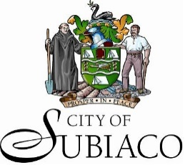

A/8244 Supply and Maintenance of Parking Fee Payment Solution
The City of Subiaco invites tenders for the supply and maintenance of devices, systems and applications to enable motorists to pay parking fees in accordance with the Specifications.

Deadline: Tenders must be received on or before 2.00PM (AWST), Tuesday 16 June 2026.
Obtaining documentation: Request for tender documents can be accessed via the City of Subiaco Tenderlink Portal: https://portal.tenderlink.com/subiaco
Tender enquiries: Further information can be requested by contacting Darren Turner via procurement@subiaco.wa.gov.au
Tender submission: Tenders must be submitted electronically via the City of Subiaco Tenderlink Portal.
Canvassing of City of Subiaco Councillors or officers will automatically disqualify any Tenderer.
COLIN CAMERON
CHIEF EXECUTIVE OFFICER

