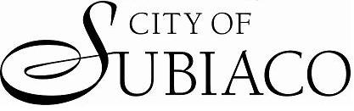
☐NEW
☐UPDATED -
Supplier Number:________
New OR UPDATED SUPPLIER DETAILS FORM

COMPLETE AND FORWARD TO procurement@subiaco.wa.gov.au
THE CITY’S PAYMENT TERMS ARE STRICTLY NETT 30 DAYS
Supplier Name:
PO Box:
Street Address:
Suburb: State: Postcode:
Contact Name:
Contact Phone:
ABN:
Accounts Receivable
Email Address:

Brief Description of what the company / individual will be supplying the Council:

Payment Method: EFT OR CHEQUE

Name of Account:
BSB No: -
Account No:
Along with this form please provide copy of the bank account details either on supplier letterhead with a signature of an authorised person within the organisation or the top section of the bank statement. No bank account details will be collected over the phone.

Requested By:
(Please Print) This MUST be completed by STAFF only
Finance Use Only
Authority Payment Terms code 1 entered Y/N?
Registered for GST Y/N?
Analysis code for ATO reporting entered = __________________________________________________________
Authorised By: 19/09/2022

